Guide for Grade Selection

Step 1: Log in your Account and Click on “Add New” under the Menu “Option Form”
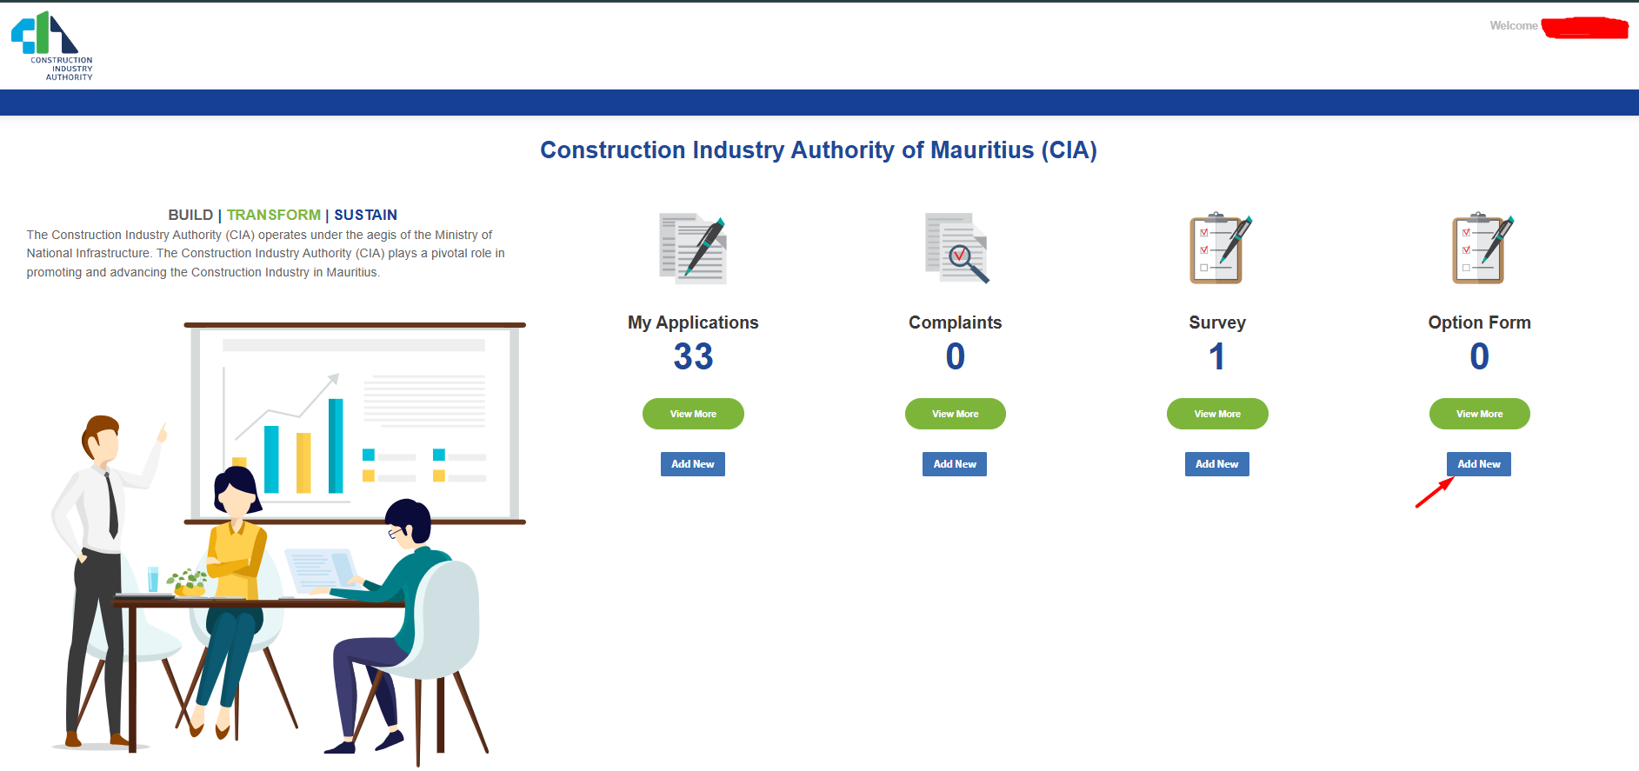

Step 2: Verification, Selection and Submission of Option Form.

- At Item 1, verify all details and ensure that the email address is correctly entered, as the new Certificate will be issued via email.

- At Item 2, select your Grade.

- At Item 3, tick the checkbox to confirm your declaration before proceeding.

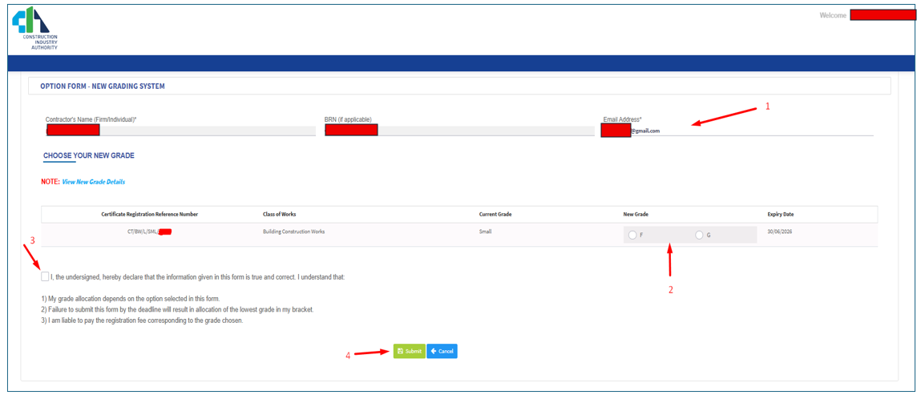
- At Item 4, submit your Option Form.

